

The Influence of Family Environment on the Academic Performance of a Student.

A FINAL PROJECT SUBMITTED FOR THE PARTIAL FULFILLMENT OF THE REQUIREMENTS OF THE ADVANCED DIPLOMA IN DATA SCIENCE (FULL TIME) PROGRAMME.

By :-
Jonathan Mishayel – (COADDS232F – 012)
Advance Diploma in Data Science
National Institute of Business Management (NIBM)
Colombo, Sri Lanka
29th August 2024

DECLARATION

I hereby declare that the work presented in this project report was carried out independently by myself and have cited the work of others and given due reference diligently.

……………………………
Jonathan Mishayel

……………………………
Date

I certify that the above student carried out his/her project under my supervision and guidance.

……………………………
Supervisor

….………………………...
Date

Acknowledgement

I take this opportunity to offer my heartiest regards to all the teachers who have assisted me in this project, especially my project supervisor Ms. Chamilanka Wanigasekara who has given me great support by guiding and encouraging me. Likewise, I would like to take this opportunity to add heartfelt respect to my friends and parents who have always supported me and helped me complete the work of this project by giving advice and guidance in various ways.

Dedication

To all the students who are dedicated for a successful future,

I dedicate this project to all those who are interested in students' performance with family environmental factors to student performance and who are trying to find a solution for it. May this help all those leading society for a healthy and peaceful future. I dedicate my hard work to a bright future for students of our age.

Jonathan Mishayel
COADDS232F-012

Abstract

This study examines the influence of selected family environment factors on students’ academic performance at the secondary education level. The dataset used in this research was obtained from a publicly available source containing academic records and questionnaire-based information from students in Portugal. The analysis focuses on family-related variables, including guardian educational level, family relationship quality, family size, parental status, family support, and student absences, with final grade serving as the dependent variable.
Multiple linear regression analysis was employed to evaluate the combined effect of these independent variables on academic performance. The findings indicate that guardian educational level, particularly higher education attainment, has a statistically significant positive impact on students’ final grades. Students whose guardians possess higher educational qualifications tend to achieve higher academic outcomes. In contrast, other family-related variables such as family relationship quality, family size, parental status, family support, and absences did not demonstrate statistically significant effects at the 5% significance level.
Although the overall regression model is statistically significant, the explanatory power remains relatively low, suggesting that academic performance is influenced by additional factors beyond the family environment variables examined in this study. The results highlight the importance of parental educational background while also emphasizing the multifaceted nature of student academic achievement.

Table of Content
Chapter 1: Introduction---------------------------------------------------------------------------1
1.1 Background---------------------------------------------------------------------------------------1
1.2 Research Problem--------------------------------------------------------------------------------2
1.3 Research Questions -----------------------------------------------------------------------------3
1.4 Scope of the research ---------------------------------------------------------------------------4
1.5 Justification of the Research -------------------------------------------------------------------5
1.6 Expected Limitations ---------------------------------------------------------------------------6
1.7 Proposed work schedule ----------------------------------------------------------------------- 7

Chapter 2: Literature Review-----------------------------------------------------------------------------9
2.1 Introduction to the research theme-----------------------------------------------------------9
2.2 Theoretical explanation about the Key Words in the Topic------------------------------10
2.3 Findings by other researchers----------------------------------------------------------------11
2.4 The research gap-------------------------------------------------------------------------------12
2.5 Table for Variables, their definitions, and sources----------------------------------------13
2.6 Chapter conclusion----------------------------------------------------------------------------14

Chapter 3: Methodology-------------------------------------------------------------------------15
3.1 Introduction-------------------------------------------------------------------------------------15
3.2 Population, sample, and Sampling technique----------------------------------------------16
3.3 Type of Data to be collected and data sources---------------------------------------------17
3.4 Data collection tools and plan---------------------------------------------------------------18
3.5 Conceptual framework------------------------------------------------------------------------19
3.6 Hypothesis--------------------------------------------------------------------------------------20
3.7 Operationalization Table----------------------------------------------------------------------21

3.8 Methods of data analysis---------------------------------------------------------------------22

Chapter 4: Data Analysis------------------------------------------------------------------------23
4.1 Data Analysis-----------------------------------------------------------------------------------23
4.2 Findings and Interpretations------------------------------------------------------------------24
Chapter 5: Discussion and Recommendations----------------------------------------------25
5.1 Discussion---------------------------------------------------------------------------------------25
5.2 Recommendations------------------------------------------------------------------------------26
5.3 Conclusions-------------------------------------------------------------------------------------27

List of References -------------------------------------------------------------------------------28

List of Tables
Table 1.1 Work Schedule--------------------------------------------------------------------------29
Table 2.1 Variable Definitions--------------------------------------------------------------------30
Table 3.1 Operationalization Table---------------------------------------------------------------31

List of Figures
Figure 3.3.1 A Rough Picture of Dataset--------------------------------------------------------32
Figure 4.1.1 Structure of the Dataset-------------------------------------------------------------33
Figure 4.1.2 Distribution of Final Grade --------------------------------------------------------34
Figure 4.2.1 Regression Analysis Test-----------------------------------------------------------35
Figure 4.2.2 Bar plot------------------------------------------------------------------------------- 36
Figure 4.2.3 Scatter Plot--------------------------------------------------------------------------- 37
Figure 4.2.4 Regression Formula---------------------------------------------------------------- 38

Chapter 1: Introduction
  - Background

Education begins within the family environment and is further shaped by the social context in which a child grows. The family is widely regarded as the fundamental unit of society and plays a central role in a child’s early cognitive, emotional, and social development. The values, support systems, and educational background present within the household can significantly influence a child’s attitudes, behavior, and academic readiness from early schooling through secondary education.
Although academic performance is affected by multiple factors including peer relationships, teacher support, communication skills, and individual effort the family environment remains one of the most influential foundations in a student’s educational journey. Parental involvement, educational background, family structure, and emotional support may shape students’ motivation, study habits, and long-term academic outcomes.
Given the increasing social and structural changes occurring within families worldwide, it is important to examine how specific family-related factors influence student performance. Therefore, this study focuses on selected family environment variables and their relationship with academic achievement at the secondary education level.

  - Research Problem

The family is the primary setting in which children begin learning social values, discipline, and responsibility. However, modern societal changes including shifts in family structure and parental roles may influence the level of support and stability experienced by students. For example, global statistics indicate measurable changes in marriage and divorce patterns (Staff, 2024), which may indirectly affect family cohesion and parent–child relationships.
Variations in parental educational level, family structure, and the quality of family relationships may create differences in the academic support provided to students. Additionally, the degree of family involvement and encouragement may influence students’ educational engagement and overall performance.
Despite the recognition that family environment plays an important role in student development, the extent to which specific family-related factors contribute to academic performance remains an area requiring empirical investigation. Therefore, this study aims to examine how selected family environment variables such as guardian educational level, family relationship quality, family size, parental status, and family support are associated with students’ final academic grades.

  - Research Question and Objective

Question:
Is there significant influence from family relationship level, family size, parent status, guardian educational level, family support and absences of a students with their final marks?

Major Objective:
Investigating the impact from family relationship level, family size, parent status, guardian educational level, family support and absences of a students with their final marks.

  - Scope of the Research

This study focuses on secondary-level students from a particular school in Portugal. The dataset was obtained from a publicly available source titled High School Student Performance & Demographics (Myrick, 2023) on Kaggle. The data were originally collected through school academic records and structured questionnaires and include information on student grades, demographic characteristics, and family-related factors. https://www.kaggle.com/datasets/dillonmyrick/high-school-student-performance-and-demographics/data
The scope of this research is limited to examining the influence of selected family environment variables on students’ academic performance. The primary variables considered in this study are guardian educational level, family relationship quality, family size, parental status (living together or apart), family support, and student absences. The dependent variable representing academic performance is the final grade.
The analysis is conducted using multiple linear regression to evaluate the combined effect of these independent variables on students’ final academic performance. The study does not attempt to examine all variables available in the dataset; rather, it focuses specifically on those aligned with the research objective concerning family environment factors.
Certain limitations must be acknowledged. The dataset represents students from a specific educational context and may not be fully generalizable to broader populations. Additionally, some data were collected through self-reported questionnaires, which may introduce response bias. Despite these limitations, the study provides a statistically structured examination of the relationship between family-related factors and student academic outcomes.

  - Justification of the Research

Education is most significant factor in human life modern world. Education is started with childhood of any human in the world. There are lot of factors which affect to the student performance in his school period. Some factors are frequently discussed and some are not. In this study, the study aims to exploring deeply the factors which have been discussed and not. Parent’ status, family relationships, guardian education and the student’s absenteeism are the more considerable key factors which can be affected in day-to-day student life. those factors are mainly focused and analyzed in this study to draw conclusions and obtain recommendations. According to the result the conclusions guide to give recommendations to hindering the impact of the factors have mentioned in above negatively to the student performance.

  - Expected Limitations

The data that we used to this study is primarily collected by another researchers, therefore this study was conducted through secondary data. The data under the preprocessing part some data could be changed and slightly skewed. Therefore, we cannot decide the all the outcomes are 100 percent accurate.
When the data was collecting, the students have given the answers for the questions. But the answers could be biased because the mental conditions and the preferences of the student and the trust about the researchers depends on each student’s answers. And also, there can be mistakes in the reports and log books that used to collect absences and other information to the data collection. Finally, overcoming these problems and challenges we can conduct good research.
  - Proposal Work Schedule

Work | Time
Find a Research Topic and Explore the topic area | 5th August 2024
Find a Data Set which Suits to the topic  Observed the variables  Preprocessed the data set | 6th August 2024
Briefly Analyzed and State the Objectives | 6th August 2024
Read the Research Papers related to the topic | 7th – 9th August 2024
Began to Write Research Proposal with Abstract and Introduction part | 10th August 2024
Literature review part | 11th August 2024
Analyzed and Write the Methodology part | 12th August 2024
Attached the References | 13th August 2024
Proofreading and Editing | 23rd August 2024
Submitted the Project Proposal | 29th August 2024

Chapter 2: Literature Review
2.1 Introduction to the Research Theme

Various behavioral and environmental factors, including inadequate parental or guardian attention, may negatively influence student academic performance. Understanding these influences is important for identifying areas where educational institutions and families can intervene to improve student outcomes.
To effectively address these concerns, it is necessary to analyze the key family-related factors that may positively or negatively affect students during their educational journey. By systematically examining these variables, this study aims to generate evidence-based conclusions and provide meaningful recommendations to support and enhance student academic performance.

2.2 Theoretical Explanation about the Key Words

Key words:
Impact, Student Performance, Relationship, Support, Family, Guardian, Alcohol Usage, Final Marks, Education
Impact – It is an effect came from the variables that we use to measure the relationship between student performance.
Student Performance – Mainly it is measured by student final marks undern the study.
Relationship – In this dataset, there are considerable relationships such as romantic relationship, family relationship and the relationship between the variables.
Support – family support and school support are main variables under the “support” key word. Also, we consider the support as the help and push from student’s backend.
Family – The student’s family environment and there are some variables start word with “family” in the dataset.
Guardian – Father or Mother probably consider as the guardian and guardian can be family member who closed to child.
Alcohol Usage – Alcohol usage divided in the study as the weekday alcohol and weekend alcohol variables. It means the alcohol consumption of a student.
Final Marks – Final marks is considered as final grade of a student.
Education – School education mainly focused in this discussion. It affects to the analysis of student performance.

2.3 Findings by other Researchers

- Using Data Mining to predict Secondary School Student Performance. (Cortez, Silva, 2008)

This research has conducted by Paulo Cortez and Alice Silva in university of Minho to predict school student performance using data mining and it is conducted by various model such as, decision trees, random forest model, neural network. they have identified the attendance of a student is crucial to their performance in academic period. As well as the parental career has the significant influence to student performance.

- Cognitive performance and academic achievement: How do family and school converge? (Alves, Gomes, Martins, 2017)

This article is published on European journal of Education and Psychology in 2017. It has conducted by Portugal Minho university students. In conclusion, this study confirms the important role of family in children’s cognitive performance and academic achievement, but school only assumes a significant impact on academic achievement. (Alves, Gomes, Martins, Almeida, 2017)

- How Family Background Influences Student Achievement. (Anna J. Egalite, 2016)

Education Next Journal Published this article in the spring in 2016. The politically inconvenient conclusion that family background explained more about a child’s achievement than did school resources ran contrary to contemporary priorities, which were focused on improving educational inputs such as school expenditure levels, class size, and teacher quality. (Anna J, 2016)

- The effects of Romantic Relationships on University Student’s Life. (Miyuki Okada, Doki Keisuke, 2017)

In general, the romantic attachment had positive influences on partners. On the other hand, negative influences were also observed, such as spending excessive time and money as a result of having a romantic partner. (Okada, Doki, 2017, Journal of Asian Regional Association for Home Economics, 2017, Vol 24, Issue 3, p86)

- Alcohol Consumption and Academic performance in a population of Spanish high school Students. (M Lopez-Friaz, J Mataix, J Llopis, 1995)
This article was published on Journal of Studies on Alcohol and Drugs. It is old article and they could not find out the significant relationship. Here are some paragraphs from conclusion part, “Although we cannot draw any conclusions about the causes of the association between academic failure and teenage drinking, our results do show that the risk of failing increases together with alcohol intake. However, it should be noted that academic achievement is also influenced by many factors other than alcohol consumption.” (M Lopez-Friaz, J Mataix, J Llopis, 1995)

- How family Background Influences student Achievement. (Barbara Nez˘ a Brec˘ko, n.d)

This research was conducted by Educational Research institute in Slovenija. After the analysis of data, the researcher could obtain a result the family background is more influenced to student performance in their primary education, as well as when they came to secondary education the relationship between parents and students become a weak relationship. (Barbara Nez˘, n.d)

- The Family School engagement and its implications on Student Performance in basic Education. (Rosa,Tatiana da ; Magalhães ,Cleidilene Ramos; Silveira,Luiza Maria de Oliveira Braga, n.d)

This study exploring the involvement with family and school by Federal University of Health Sciences of Porto Alegre. This research has identified the effect of teach to the student is more significance than the parent involvement with student. (Rosa,Tatiana da ; Magalhães ,Cleidilene Ramos; Silveira,Luiza Maria de Oliveira Braga, n.d)

- The Impact of Interpersonal Stress in Romantic Relationships on College Students’ Mental Health and Academic Performance. (Linda, 2016)
This Research was conducted by Texas university student to measure the significance of the stress level of a student in romantic relationship other than any relationship. In conclusion chapter obtained that There is evidence that interpersonal stress experienced in the context of a romantic relationship may have a particularly severe impact on mental health and well-being. This is due to interdependent nature of romantic relationships and intense emotion associated with an intimate relationship (Vangesti, 2007).

- Drugs and Substance Abuse among the Secondary School Students in Korogocho: Implications for Behavior and Performance. (Ondigo,Quinter ; Birech ,Jeniffer ; Gakuru,Octavian N., 2019)

Quinter Ondigo, Jeniffer Birech2 & Octavian N. Gakuru conducted this research under the department of sociology, university of Nairobi. The study revealed that marijuana, miraa, alcohol and cigarettes are the most abused drugs by secondary school students and had eroded the core values hence affecting their social skills development and academic performance. (Ondigo,Quinter ; Birech ,Jeniffer ; Gakuru,Octavian N., 2019)

- The Relationship between Students' Study Time and Academic Performance and its Practical Significance. (Liu, 2022)

This study investigates the relationship between study time and academic performance by analyzing the number of selected courses, study time, and grades provided by open-source data sites.studies have observed a positive relationship between study time and academic performance. (Liu, 2022)

2.4 Research Gap
Previous studies have widely examined the relationship between family background and student academic performance. While parental education and socio-economic status have received considerable attention, other family environment factors such as family relationship quality, family structure, family size, and family support are less frequently analyzed together within a single statistical model.
Therefore, this study aims to address this gap by examining the combined influence of selected family environment variables on students’ academic performance using multiple linear regression analysis.

2.5 Table for Variables (Definition & Source)

Variable | Type | Definition | Source
Student ID | Unique | Every student who has participated to the research has unique ID | Online free source
Sex | Categorical | Student Sex (Male & Female) denoted by M/F | Online free source
Age | Numerical | Student’s Age (15 to 22) | Online free source
Family Size | Categorical | The count of family members (“Less than or equal to 3” / “Greater than 3”) | Online free source
Guardian Education | Categorical | It is education level consisted with “primary education (4th grade)” / “grade 5th to 9th ” / “secondary education”/ “higher education” | Online free source
Guardian | Categorical | The guardian of the student(mother/father/other) | Online free source
Study time | Categorical | It is weekly study time (“<2 hours”/ “2 to 5 hours” / “5 to 10 hours” / “>10 hours”) | Online free source
School support | Categorical | Extra educational support from school (yes/no) | Online free source
Family support | Categorical | Family educational support | Online free source
Extra paid classes | Categorical | Extra paid classes within the course subject (yes/no) | Online free source
Higher education | Categorical | Higher education purpose of the student (yes/no) | Online free source
Romantic relationship | Categorical | With a romantic relationship (yes/no) | Online free source
Family relationship | Categorical | Quality of family relationship (numeric indicator: from 1-low to 5-high) | Online free source
Weekday alcohol | Categorical | Weekday alcohol usage for a student (numeric indicator: from 1-low to 5-high) | Online free source
Weekend alcohol | categorical | Weekend alcohol usage for a student (numeric indicator: from 1-low to 5-high) | Online free source
absences | Numerical | The total days of the student did not attend the school educational days. | Online free source
Grade 1 | Numerical | First period grade (0 to 20) | Online free source
Grade 2 | Numerical | Second period grade (0 to 20) | Online free source
Final grade | Numerical | Final Grade (0 to 20) | Online free source

2.6 Chapter Conclusion
The research about measuring the impact from the factors that we have mentioned above to student performance. Exploring the previous researches, we could not find considerable evidence through some factors to this study. Therefore, the researcher eager to create a framework to investigate the impact controlling some factors and criteria under the methodology chapter.

Chapter 3: Methodology

3.1 Introduction to Methodology

The dataset used in this study was obtained from a publicly available source containing academic records and questionnaire-based information collected from students in a secondary school in Portugal. The data include information derived from school record books as well as structured questionnaires completed by students. As the study is based on secondary data from a specific school context, the findings may be limited in generalizability.
Prior to analysis, the dataset was preprocessed to ensure consistency and accuracy, including appropriate handling of missing values. However, as some variables were based on self-reported questionnaire responses, a degree of response bias may exist.
The research objectives and questions were addressed using multiple linear regression analysis conducted in R. Data visualization techniques were also employed to support interpretation and provide a clearer understanding of the relationships between selected family environment variables and students’ academic performance.

3.2 Population, Sample, Sampling Technique

Population – Under the Study, The Investigation is conducted among students in school education as a population.

Sample – Sample is the subset of the population those who are studying at the school in secondary level.

Sample Technique – To collect the data about population through the sample, the data collector has used random sampling technique.

3.3 Type of Data to be Collected and Data Source
The data set available on the Kaggle which is online free data source. According to the description, the data set was collected by some particular school in Portugal. Including the demographics of a student, and parental status, and their impact to the student in various factors as variables. The numerical and categorical variables also available in the dataset. The primary data has been processed in the preprocessing part. The data was collected by the school reports and questionaries in reliable way.
Here the Data Set:
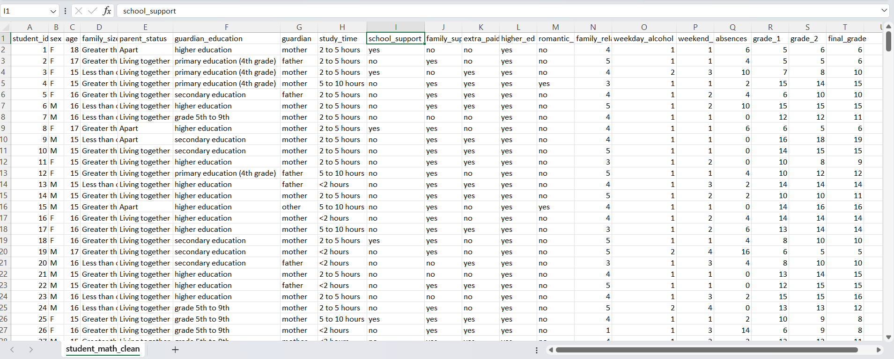
(source: https://www.kaggle.com/datasets/dillonmyrick/high-school-student-performance-and-demographics )

3.4 Data Collection Tools and Plan

Data Collection was Compiled by some data collecting tools, such as surveys /questionaries and the documents (record book, student performance reports and log books). The questionaries are consisted with open ended questionnaire. The responses which have been given by the students can be divided in to qualitative data and quantitative data. Those type of balanced data included very well in the dataset to continue the research into the plans and goals which the researcher has been already.

3.5 Conceptual Frame Work

This Study is based on the investigating the impact of family environment and other relationships to the student performance. The way of conducting research conceptual framework is a guiding map. According to the framework first work is clearly identifying and stating the objectives that we want to achieve as our goals through various methods and tools. In the journey of going to the analysis the statistical tests are crucial. In this study hope to use regression analysis to measure the strength of the relationship between numerical variables to final grade. In the categorical variables which has consisted with 3 more categories also we use regression test and less than 3 categories also multiple linear regression to examine the impact to the final grade which indicate the student performance. When achieving some particular objective, we’ll do the visualization as well as to take clear idea about the spread and the distribution of data to draw better conclusions and recommendations.

3.6 Hypothesis
Major Objective:

H₀ – There is no significant relationship between family relationship level, family size, parent status, guardian educational level, family support and absences of a students with their final marks.
H₁ – There is a significant relationship between family relationship level, family size, parent status, guardian educational level, family support and absences of a students with their final marks

3.7 Operationalize Table

Variable | Definition | Indicators | Measures | References
Guardian Education | The level of the education of the guardian | - Primary education  - Grade 5th to 9th  - Secondary education  - Higher education | Categorical (Ordinal) | Survey
Final Grade | The final marks of a student | 0 to 20 range | Numerical | Student performance reports
Family Relationship | The degree of the relationship with family and student | From 1-low to 5-high | Categorical (Ordinal) | Survey
Family Size | The number of members of a student family. | Greater than 3  Or  Less than or equal 3 | Categorical  (Nominal) | Survey
Family Support | A student has support from their family. | Yes / No | Categorical (Nominal) | Survey
Absences | Sum of the days the student did not attend | 1-100 count | Numerical | Record book
Parent Status | The marital status of the parents. | Apart  Or  Living Together | Categorical  (Nominal) | Survey

3.8 Methods of Data Analysis

Multiple Linear Regression Analysis for family relationship level, family size, parent status, guardian educational level, family support and absences of a students with their final marks. (There are more than two independent variables.) Use Scatter plot, Bar plot, density plot to visualize the student performance factor’s details using R programming language with their final grade.

Chapter 4: Data Analysis
4.1 Data Analysis
Introduction to Data Analysis
Under the data analysis part, the study is committed to deliver comprehensive overview of the data by investigating the inter relationships of variables, the distribution of data of both categorical and numerical factors. Especially, the regression analysis and data visualization techniques are used to obtain the insights from this study.
Also, data analysis is important to draw conclusions and to give recommendations through the study.

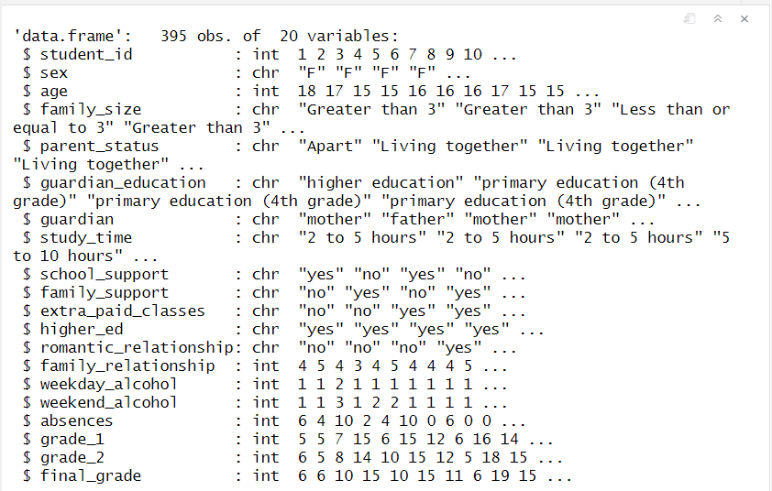
Figure 4.1.1 structure of the dataset

The data set is consisted with 20 variables and we do not use the all variables in this analysis. There are 395 observations in data set and the variables have two major types ‘int’ and ‘chr’. There are 5 numerical variables and 14 categorical variables. Mainly used variables under the research are final grade, guardian education, weekday alcohol consumption, absenteeism, family relationship level. And those variables use throughout the study. There are no missing values in the data set. All of other explanations about the data set are included in previous chapters.

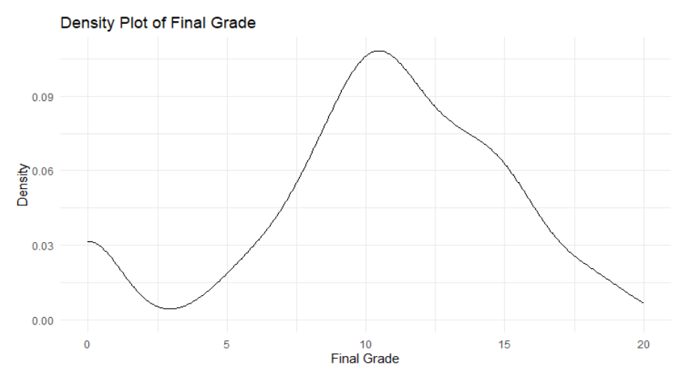
Figure 4.1.2 Distribution of Final Grade
Density distribution of students’ final grades. The plot illustrates the overall distribution pattern, showing that most students scored around the mid-range (approximately 9–13), with fewer students achieving extremely low or high grades.

4.2 Findings and Interpretations
4.2.1 Major Objective

Objective - Investigating the impact between family support, family size, family relationship, guardian educational level, parent’s status and absences with student’s final grade.
Regression analysis is used to analyze the major objective. It has one numerical dependent variable and for nominal categorical independent variables and one numerical independent variable and ordinal categorical variable. R programming language is most appropriate language to achieving this objective using multiple linear regression analysis as well as to demonstrate the result.

- Dependent variable – final grade

- Independent variables – family relationship level, family size, parent status, guardian educational level, family support and absences of a student

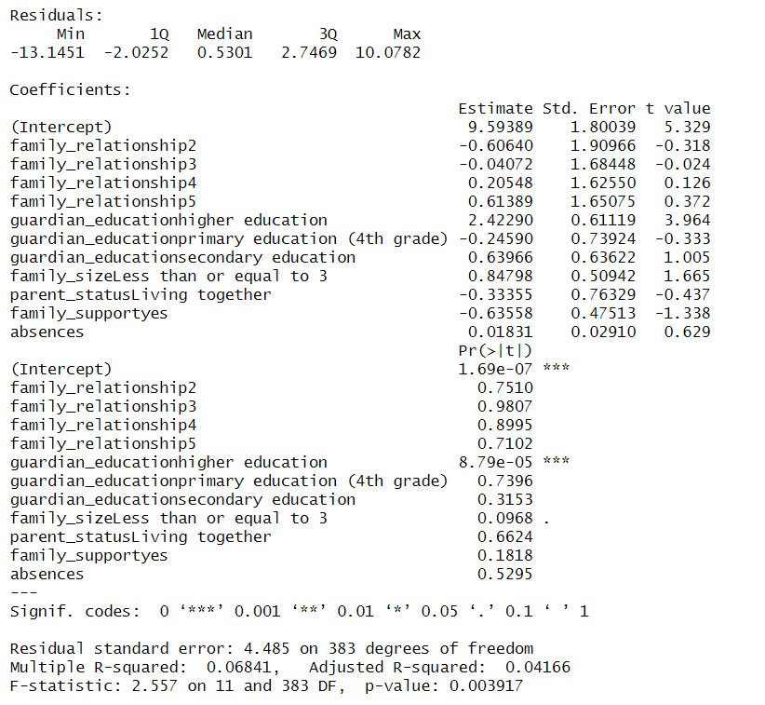
Figure 4.2.1 Regression output for the objective

Hypothesis,
H₀ – There is no significant relationship between family relationship level, family size, parent status, guardian educational level, family support and absences of a student to their final grade.
H₁ – There is a significant relationship between family relationship level, family size, parent status, guardian educational level, family support and absences of a student to their final grade.

According to the model, the overall p value indicates 0.003917. It is very low when it compares with significance level 0.05. therefore, the null hypothesis can be rejected, and Alternative hypothesis is accepted that There is a significant relationship between family relationships, weekday alcohol usage, absences, and guardian education level to student’s final grade at significance level 0.05. Also, the significant codes “***” indicates near 0 shows the impact from those independent variables is significant.

Interpretation of Residuals
Residuals represent the difference between the observed and predicted values of the final grade.
- Minimum residual: -13.1451 (largest negative deviation)
- Maximum residual: 10.0782 (largest positive deviation)
- 1st Quartile (25th percentile): -2.0252
- Median (50th percentile): 0.5301
- 3rd Quartile (75th percentile): 2.7469
These values indicate that the prediction errors are distributed around zero, with some moderate deviations. The residual standard error of 4.485 suggests that, on average, the predicted final grades differ from the observed values by approximately 4.5 points on a 0–20 grading scale.
Interpretation of Estimated Coefficients
When interpreting the regression coefficients, each effect is examined while holding other variables constant.
1) . Family Relationship (Reference Level: Level 1)
Compared to the reference category:
- Level 2: coefficient = -0.60640, p = 0.7510
- Level 3: coefficient = -0.04072, p = 0.9807
- Level 4: coefficient = 0.20548, p = 0.8995
- Level 5: coefficient = 0.61389, p = 0.7102
All p-values are greater than 0.05. Therefore, family relationship levels do not have a statistically significant effect on final grade in this model.

2) . Guardian Educational Level (Reference: 5th–9th Grade)
- Higher education: coefficient = 2.42290, p = 8.79e-05
Statistically significant (p < 0.05). Students whose guardians have higher education score approximately 2.42 points higher on average compared to the reference group.
- Primary education (4th grade): coefficient = -0.24590, p = 0.7396
Not statistically significant.
- Secondary education: coefficient = 0.63966, p = 0.3153
Not statistically significant.
Thus, only higher guardian education shows a significant positive impact on student academic performance.
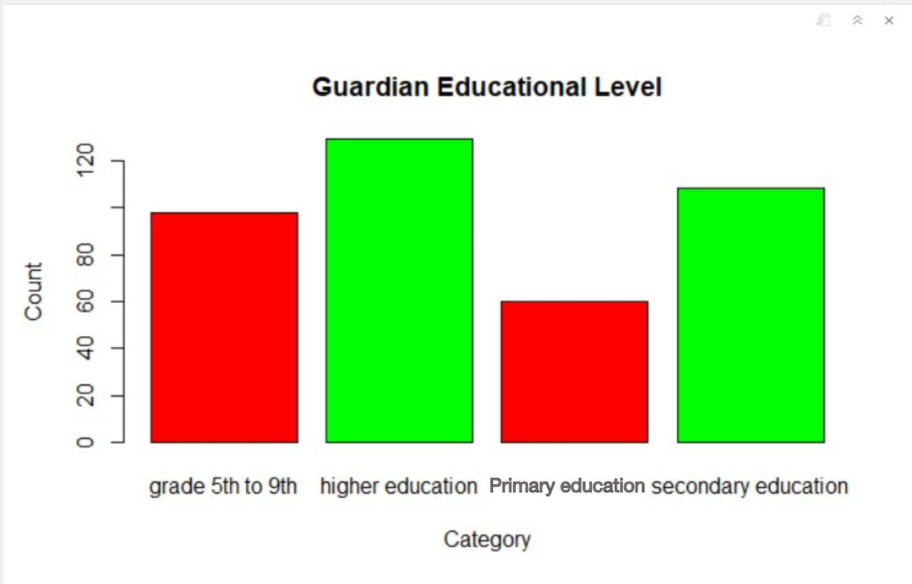
Figure 4.2.2 Bar plot for Guardian Education by Count
3) . Family Size (Reference: Greater than 3)
- Less than or equal to 3: coefficient = 0.84798, p = 0.0968
This variable is not statistically significant at the 5% level, but it shows marginal significance at the 10% level. Students from smaller families tend to score slightly higher, although the evidence is weak.

4) . Parent Status (Reference: Apart)
- Living together: coefficient = -0.33355, p = 0.6624
This variable is not statistically significant. Parental living status does not show a meaningful effect on final grade in this model.

5) . Family Support (Reference: No)
- Yes: coefficient = -0.63558, p = 0.1818
Family support does not have a statistically significant effect on final grade. The negative coefficient suggests a slight decrease in predicted grade; however, this effect is not statistically significant.

6) . Absences
- Coefficient = 0.01831, p = 0.5295
Absences do not have a statistically significant impact on final grade. The estimated effect is very small and statistically insignificant.

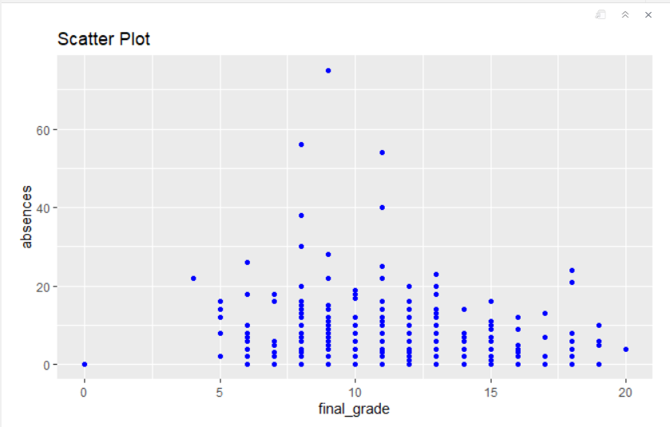
Figure 4.2.3 Scatter Plot
The scatter plot shows the visual interpretation of the relationship between absences and final grade. Some points deviate in the data set and some points are tightly stored. However, according to the chart we can see particular pattern students who are under the 20 days in absences have gotten slightly higher final grade.

All the coefficients of the variables can be indicated through regression equation like this,

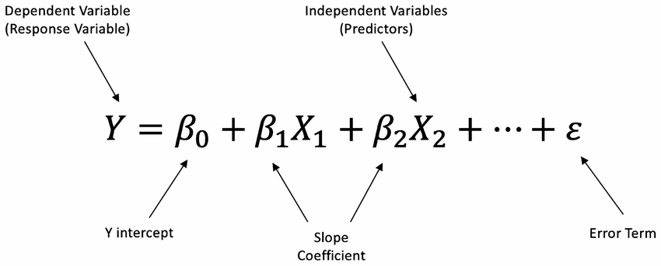
Figure 4.2.4 Regression Equation formula

The intercept of the model is 9.59389. This represents the predicted final grade when all independent variables are at their reference categories and numerical predictors are equal to zero.
The regression equation can be expressed as:
Ŷ = Predicted Final Grade
F-statistic = 2.557
p-value = 0.003917
Since the p-value (0.003917) is less than the significance level of 0.05, the overall regression model is statistically significant. This indicates that at least one of the independent variables included in the model has a statistically significant relationship with the final grade.
The Residual Standard Error is 4.485. This value represents the average deviation between the observed and predicted final grades. On a grading scale of 0–20, this suggests that predicted values differ from actual grades by approximately 4.5 points on average.
The Multiple R-squared value is 0.06841 (6.84%), meaning that approximately 6.84% of the variation in students’ final grades is explained by the independent variables included in this model. The Adjusted R-squared is 0.04166 (4.17%), which accounts for the number of predictors in the model.
It is important to note that statistical significance is determined by the p-value rather than the R-squared value. Although the model is statistically significant based on the F-test, the R-squared value remains relatively low. This indicates that while the model detects at least one significant predictor (guardian education – higher education), its overall explanatory power is limited. Therefore, a substantial proportion of the variation in final grades (over 90%) is influenced by other factors not included in this model.

Chapter 05: Discussion and the Recommendations

5.1 Discussion
The main objective of this study was to examine the influence of selected family environment factors on students’ academic performance, measured by final grade, using multiple linear regression analysis.
The results indicate that among the selected variables, only guardian educational level (higher education) has a statistically significant positive impact on students’ final grades. Students whose guardians possess higher education qualifications score, on average, approximately 2.42 points higher than those in the reference category (5th–9th grade education level). This suggests that parental educational background plays a meaningful role in shaping students’ academic outcomes. Educated guardians may provide better academic guidance, learning support, and motivation at home.
In contrast, other family-related variables—including family relationship quality, family size, parental status (living together or apart), and family support—did not show statistically significant effects at the 5% significance level. Although some variables displayed small positive or negative coefficients, their p-values indicate that these relationships are not statistically strong within this dataset.
Family size showed a marginal effect at the 10% significance level, suggesting that students from smaller families may perform slightly better academically; however, this evidence is weak and should be interpreted cautiously.
Absences also did not demonstrate a statistically significant relationship with final grade in this model. While attendance is generally considered important for academic success, the regression results suggest that its effect is minimal when considered alongside the selected family variables.
Overall, although the model is statistically significant, its explanatory power remains relatively low (R² ≈ 6.8%). This indicates that academic performance is influenced by many additional factors not included in the present study, such as personal motivation, cognitive ability, teaching quality, and prior academic achievement.

5.2 Recommendations

Strengthening Parental Educational Support
Since guardian education level (particularly higher education) shows a significant positive impact on student performance, educational institutions and policymakers should consider developing programs aimed at supporting parents with lower educational backgrounds. Parent education workshops and academic guidance programs may help guardians better assist their children’s learning processes.

Enhancing Family Engagement
Although family relationship quality and family support were not statistically significant predictors in this model, maintaining a stable and supportive family environment remains important for students’ overall well-being. Schools may encourage parental involvement in school activities and communication between teachers and families to foster a positive academic atmosphere.

Supporting Students from Larger Families
Given the marginal relationship observed with family size, targeted academic support programs may be beneficial for students from larger households, where resources and parental attention may be more limited.

Monitoring Attendance
While absences were not statistically significant in this model, regular school attendance remains essential for effective learning. Schools should continue implementing attendance monitoring systems and early intervention strategies to prevent long-term academic difficulties.

5.3 Conclusions

This study aimed to examine the influence of selected family environment factors on students’ academic performance, measured by final grade, using multiple linear regression analysis. The variables considered included guardian educational level, family relationship quality, family size, parental status, family support, and student absences.
The findings indicate that among the selected predictors, only guardian educational level specifically higher education has a statistically significant positive impact on students’ academic performance. Students whose guardians possess higher educational qualifications tend to achieve higher final grades compared to those whose guardians have lower educational attainment. This result highlights the important role of parental educational background in shaping academic outcomes.
Other family-related variables, including family relationship quality, family size, parental status, and family support, did not show statistically significant effects at the 5% significance level. Although some variables displayed slight positive or negative trends, the evidence was not strong enough to confirm a meaningful statistical relationship within this dataset. Additionally, student absences did not demonstrate a significant impact when analyzed alongside the selected family environment factors.
While the overall regression model was statistically significant, the explanatory power of the model was relatively low (R² ≈ 6.8%). This suggests that academic performance is influenced by a wide range of additional factors not included in this study, such as individual motivation, cognitive ability, prior academic performance, teaching quality, peer influence, and socio-economic conditions.
In conclusion, the study confirms that guardian educational level is an important family-related factor associated with student academic success. However, family environment alone does not fully explain variations in student performance. Future research may incorporate additional psychological, behavioral, and academic variables to develop a more comprehensive understanding of the determinants of student achievement.
References

Anna J, e. (2016). How Family Background Influences Student. Education Next, 16. Retrieved from https://educationnext.org/ednext-podcast-how-much-does-family-background-affect-student-achievement/
Linda, L. B. (2016). The Impact of Interpersonal Stress in Romantic Relationships on College Student's Mental Health and Academic Performance. Faculty of the Graduate School of the University of Texas.
Liu, M. (2022). The Relationship between Students' Study Time and Academic Performance and its Practical Significance. Queen’s University, Kingston, K7L 3N6, Canada .
Ondigo,Quinter ; Birech ,Jeniffer ; Gakuru,Octavian N. (2019). Drugs and Substance Abuse among the Secondarey School Students in korogocho: Implications for Behaviors and Performance. Institute of Research Advances.
Rosa,Tatiana da ; Magalhães ,Cleidilene Ramos; Silveira,Luiza Maria de Oliveira Braga. (n.d). THE FAMILY-SCHOOL ENGAGEMENT AND ITS IMPLICATIONS ON STUDENT. Psicologia Escolar e Educacional.
staff, D. (2024). Divorce Rates in the World: Divorce Rates by Country. Divorce statistics. Retrieved from https://divorce.com/blog/divorce-rates-in-the-world/#:~:text=In%202022%2C%20using%20the%20available,per%201%2C000%20people%20in%202023.
staff, D. (2024). Divorce Rates in the World: Divorce Rates by Country. Retrieved from https://divorce.com/blog/divorce-rates-in-the-world/#:~:text=In%202022%2C%20using%20the%20available,per%201%2C000%20people%20in%202023.

Jonathan Mishayel
Advance Diploma in Data Science
National Institute of Business Management (NIBM)
Colombo, Sri Lanka
16th August 2024

